Among Friends, in collaboration with the Regional Training Co-Op offers
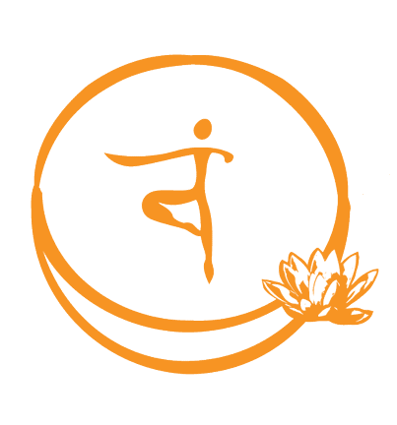
OIS© Level G - Portland
Facilitated by: Shanya Luther, M.Div

DATES: Thursday and Friday / February 21-22, 2019
TIME: 9:00am – 5:00pm
COST: $105 covers class, materials and light snacks

CONTACT: Cara Wiggins, Training Coordinator
trainings@among-friends.org

LOCATION: Department of Human Services -Training Center
(You must enter at EAST entrance)
11826 NE Glisan St., Portland, OR 97220
See Google Map

REGISTER: 1. Fill out the registration form using this link:
OIS Training Registration Form
2. You will be sent an online invoice via email. Your spot is not confirmed until the invoice has been paid.

*IMPORTANT* to remember:
- You MUST pay the registration invoice in advance. (see #2 under registration)
- You MUST attend the entire training. Check the map ahead of time to be sure you know where you’re going, and plan extra time to ensure you find parking and arrive on time.
- You MUST dress in athletic clothes and shoes.
- We highly recommend you dress in layers for different temperatures.
- We suggest you bring a pen, paper and sack lunch. (food can be hard to find nearby)

Who Should Attend This Training?:
Professionals who work with adults with Intellectual or Developmental Disabilities who want to understand challenging behaviors and how to deescalate a crisis. (For example: Foster Care Providers, Personal Agents and Service Coordinators, PSW’s, Provider Agency Staff, etc.)

Description:
Oregon Intervention System (OIS) is an intensive training/certification program for understanding challenging behaviors and the process for implementing Positive Behavior Support and safe intervention when addressing challenging behaviors. This two day OIS-G class focuses on supports for adults with I/DD in the home or community.

Shanya Luther is a social-sexual ecologist. She owns and operates Among Friends;
offering trainings and consultation. Learn more at Among-Friends.org

