Albertina Kerr, as part of the Region 1 DD Training Co-Op offers:

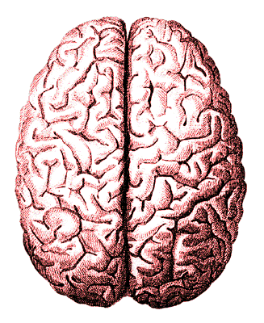
Topic: Fetal Alcohol Spectrum Disorders
Presenter: Lori Thompson, MS Ed

Date: Monday, July 16, 2018
Time: 9am - 12noon

Class site: East County Police Station (parking across the street)
737 SE 106th Ave.,
Portland, OR 97216
Cost per registrant $25 (Co-Op member rate*)
*Member agency staff, foster providers, & families of individuals in DD services get Co-Op rate, but DOUBLE for others.
Course Description: Fetal Alcohol Spectrum Disorders are the leading cause of Intellectual Disabilities. The term refers to conditions such as: Fetal Alcohol Syndrome, Fetal Alcohol Effects, Alcohol-Related Neuro-Developmental Disorder and Alcohol –related birth defects. Often the disability is invisible and the person is misunderstood, labeled as lazy and considered to be “difficult to work with.” The distinct compromises in executive functioning created by exposure to alcohol can lead to myths and misconceptions about the working memory, inferential reasoning skills and information processing.
This training is geared towards anyone supporting an individual living with the cognitive and adaptive effects of Fetal Alcohol Spectrum Disorder in a family home, a group living arrangement or a foster care setting. Participants will be provided information about the diagnosis and the specific impact on one’s learning and behavioral exhibitions. A new perspective about the underlying function of many challenging behaviors associated with FASD will be made available to participants throughout the training.
This workshop will help participants understand the damage that alcohol can have on the developing brain and provide practical strategies that are most effective when dealing with FASD within a family setting, foster home environment, group home and/or day program. Individuals with Fetal Alcohol Spectrum Disorders present increasing challenges and often utilize a large portion of community based crisis stabilization services. This workshop is highly recommended for anyone who provides support services to individuals within the I/DD community. The presenter, Lori Thompson, M.S. Ed, has over 40 years of experience working in the field of intellectual and developmental disabilities.
Contact: Carol Dinsmore e-mail: carold@albertinakerr.org or 503-262-0158

REGISTRATION FORM: “Fetal Alcohol Spectrum Disorders” 7.16.18

Name(s) Phone Number E-mail

Agency Foster Home (Yes_/No_) Mail address City State/ZIP
Region 1 Training Co-Op member Yes__ / No__ (Fee DOUBLES for non-members-see above)

Amount enclosed $ ________ payable to: Albertina Kerr: 722 NE 162nd Ave., Port, OR 97230

