Among Friends, in collaboration with the Regional Training Co-Op offers
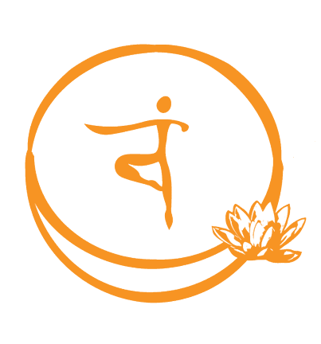
OIS© The Oregon Intervention System – Level G
Facilitated by: Shanya Luther, M.Div

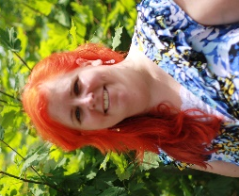
DATES: Thursday and Friday / Sept 13-14, 2018
TIME: 9:00am – 5:00pm
COST: $100 covers class, materials and light snacks

CONTACT: Cara Wiggins, Training Coordinator
registration@among-friends.org

LOCATION: INW Conference Room
919 NE 19th Avenue Suite 275 / Portland, Oregon
See Google Map

REGISTER: 1. Fill out the registration form using this link:
OIS Training Registration Form
2. You will be sent an online invoice via email. Your spot is not confirmed until the invoice has been paid.

*IMPORTANT* to remember:
- You MUST pay the registration invoice in advance. (see #2 under registration)
- You MUST attend the entire training. Check the map ahead of time to be sure you know where you’re going, and plan extra time to ensure you find parking and arrive on time.
- You MUST dress in athletic clothes and shoes.
- We highly recommend you dress in layers for different temperatures.
- We suggest you bring a pen, paper and sack lunch. (food can be hard to find nearby)

Who Should Attend This Training?:
Foster Care Providers, Personal Agents and Service Coordinators, PSW’s, Provider Agency Staff, and anyone who wants to understand challenging behaviors and how to deescalate a crisis.

Description:
OIS is an intensive training/certification program for understanding challenging behaviors and the process for implementing Positive Behavior Support and safe intervention when addressing challenging behaviors. This two day OIS-G class focuses on supports for adults with intellectual or developmental disabilities in the home or community.

Shanya Luther is a social-sexual ecologist. She owns and operates Among Friends;
offering trainings and consultation. Learn more at Among-Friends.org

